Programming for Game Design Final Project Proposals
- Fantasy fall catching game:
  - Pixelated visuals + chill background music
  - One type of armour falling from the top of the screen (ex. breastplate)
  - Poison bottle falling from top of screen
  - Player character on the ground, can move left and right
  - If armour makes contact with character, +1 point
  - If poison bottle makes contact with character, -1 point
  - Make time up screen (ex. 1 minute playing time) with score
  - Restart screen
Extension ideas
- Make start screen with start button
- Make a starting screen with a short story of character’s lore
- Make enter name text box for character
- Make level up screen where after you complete 3 levels, you get to choose another character avatar
- Gain a pet (ex. Pixel cat) as the reward for completing the first level (with PVector Chaser)
- Different sounds for when armour hits character or when poison bottle hits character
- Different items = different points/boosters
Potential hurdles:
- Making different screens (ex. Start screen, end screen, level up screen etc.) could be more complicated
- Creating random (but mostly armour) selection more armour than poison bottles

Second game idea:
- Dessert matching game
  - Pixelated visuals + chill background music
  - Start off with all brown face down circles (around 20)
  - Pick a circle, need to find the corresponding dessert
  - Flipped over corresponding dessert pairs stay face up (visible), leaving only unmatched desserts still face down and brown
  - If match wrong desserts together, both flip back to face down
  - Make time up screen (ex. 1 minute playing time) with score/end of game screen if finished before time up
Extension ideas
- Make different levels (more difficult levels = smaller time frame)
- Have boosters that you earn as you play more levels (ex. Time booster adds 15 seconds to the clock or Take a Peek booster flashes all of the desserts for 1 second on the screen)
- Progression continues, make harder by swapping the circles around

Potential hurdles
- Matching the actual desserts because they are not solid colours (actual patterns and designs), how to do Boolean?
- Getting the wrongly matched desserts to flip over again

Game idea 1: Project proposal timeline
Comprehensive List of Major Coding Concepts & Techniques
Here are the concepts you'll need, from fundamental to more advanced.
Core Programming Concepts:
- Variables: To store things like the player's x, y position, the current score, the gameState (start, playing, end), and a timer.
- Conditionals (if, else if, else): To check for collisions, see if the game time is up, or determine what screen to show.
- Loops (for loop): To iterate through arrays of falling objects (armour and poison). This is crucial.
- Functions/Methods: To organize your code. You'll have setup(), draw(), and should create your own like spawnItem(), checkCollisions(), displayStartScreen().
- Boolean Logic: Using && (AND) and || (OR) in your conditionals, e.g., if (itemY > height && itemType == "armour").
Processing-Specific Concepts:
- The setup() and draw() functions: The backbone of every Processing sketch.
- Drawing Shapes (rect(), ellipse()) and Handling Colors: For your pixelated visuals.
- Keyboard Input (keyPressed, keyCode): To move your player left and right.
- Arrays/Lists (Array or ArrayList): This is one of the most important concepts for your game. You'll need an array to manage all the falling items on the screen. An ArrayList is often easier for this as it can grow and shrink dynamically.
- Objects and Classes: You will create an Item class (or separate Armour and Poison classes). This is the best way to manage the properties (x, y, type, speed, image) and behaviors (fall, display) of each falling object.
- PVectors: A handy class to store (x, y) coordinates and velocities. Useful for your player, items, and your extension idea for the pet chaser.
- Collision Detection: Simple rectangle-rectangle collision using if (rect1X < rect2X + rect2Width && ...).
- State Management: Using a variable (like gameState) to control whether the start screen, game, or end screen is displayed. This is key to your "hurdle" #1.
- Random Number Generation (random()): To spawn items at random x-positions and to control the ratio of armour to poison.
- Timing (millis()): To create your 1-minute game timer. You'll store a startTime and check if millis() - startTime > 60000.
- Images (PImage): To display your pixel art for the player, armour, and poison.
- Sound (import processing.sound.*;, SoundFile): To play your background music and sound effects.
- Text Display (text(), textAlign(), textSize()): For the score, timer, and all screen text.

Trickiest/Most Complicated Concepts for a Beginner
  - Objects and Classes: Understanding the difference between a class (the blueprint) and an object (the actual thing), and how to make them interact, is a big conceptual leap.
  - Arrays/ArrayLists of Objects: This combines two difficult concepts. The mental model of "I have a list, and each element in that list is a complex object that has its own data and functions" can be challenging at first.
  - State Management: Switching between different screens (start, game, end) without the code becoming a tangled mess of if statements is a common hurdle. Planning this structure from the beginning is vital.
  - Collision Detection with a List: The logic isn't just checking one object against another; it's checking the player against every single object in the list. This requires a loop and can be tricky to debug.

Ordered Step-by-Step Plan to Tackle the Project
Follow this order. Only move to the next step when the current one is working perfectly.
Phase 1: The Absolute Core Gameplay (The "MVP" - Minimum Viable Product)
Use simple shapes (rectangles) for everything at this stage.
  - The Player: Create a rectangle at the bottom of the screen that moves left and right with the arrow keys. Store its position in variables.
  - A Single Falling Object: Create one falling rectangle that starts at the top and moves down. Give it properties (x, y, speed) using variables.
  - Multiple Falling Objects (The Big Leap):
a. Create an Item class with properties for x, y, speed, and type (e.g., "armour" or "poison").
b. Create an ArrayList<Item> to hold your items.
c. Write a function that, when called, creates a new Item with a random x-position and adds it to the ArrayList.
d. In draw(), use a for loop to go through the ArrayList and update/display each item.
  - Spawning and Scoring:
a. Use random() in your spawn function to sometimes create "armour" and sometimes "poison". Start with a 50/50 chance to test.
b. In your collision detection loop, check the type of the item. Increase the score for armour, decrease it for poison.
c. When an item is caught or goes off the bottom of the screen, remove it from the ArrayList.
Phase 2: Polish the Core Game
Now you have a functional game! Let's make it proper.
  - The Timer: Implement the 1-minute timer using millis(). When time is up, stop the game loop and display the final score on top of the game screen.
  - Graphics: Replace all your rectangles with your pixel art using PImage. Load your images in setup() and draw them in the appropriate display() functions.
  - Game Balance: Adjust the random() logic in your spawn function to make armour more common than poison (e.g., 70% chance for armour, 30% for poison).
  - The Start Screen: Write an if (gameState == "START") block in draw(). Display your start screen here. Make a "Start" button (a rectangle) and add code in mousePressed() to check if the mouse is over that button. If it is, set gameState = "PLAYING" and reset the score/timer.
  - The Game Over/Restart Screen: When the timer ends, set gameState = "GAME_OVER". In draw(), display the final score and a "Restart" button. Make the button reset the game and set the state back to "PLAYING".
  - Sound: Add background music (loop it) and simple sound effects for catching items.
  - Story/Name: Add a new game state, "STORY", that appears after the start screen. Use text() to display your lore and an input box for the name.
  - The Pet Chaser: This is an advanced but great extension.
a. Create a Pet class that has a PVector position and PVector velocity.
b. In its update() function, use the simple chasing algorithm: velocity = PVector.sub(player.position, pet.position); velocity.normalize(); velocity.mult(speed); position.add(velocity);.
This plan breaks down a potentially overwhelming project into manageable, logical chunks. Good luck, and have fun building your game! You've got a solid plan.

Daily Journal:
Goals for the day:
Today I accomplished:
Problems I encountered:
Notes for next class:

11/4/2025
Goals for the day: create the basic objects (player that can move using A and D keys and won’t go offscreen and possibly set up an arraylist for falling objects). I will be using rectangles as placeholders before I import character and object designs into the game in a future class.
Today I accomplished: I made a player that is at the bottom of the screen, can be controlled using A and D keys to move left and right (using KeyPressed2024), and cannot go off screen. I also made falling objects that spawn at random locations and fall at a certain speed (using “Single Raindrop Spawn from diff location).
Problems I encountered: I forgot to change the variable x and y into x2 and y2 for the falling objects, so it made the falling objects able to be controlled using A and D instead of the player.
Notes for next class: start on collision code (look at bulletArrayList code for reference).

11/6/2025
Goals for the day: Make the code so that when the falling circle hits the player, it disappears. Also figure out how to make 70/30 chance of white ball to green ball (poison) but still have them spawn at random positions.
Today I accomplished: I made the collision code today where the falling object disappears after coming in contact with the player. I also made the 70/30 chance code that spawns 70% white balls and 30% green balls using a Boolean.
Problems I encountered: My 70/30 code was placed within the collision code which meant that if my player did not come in contact with the falling object, the 70/30 code would not apply, and the falling balls afterwards would all be white. I fixed this by placing the 70/30 code outside of the collision code so that even if the player did not come in contact with the falling object, the 70/30 code still applies to the balls that fall after the miss.
Notes for next class: Find the example where multiple falling objects spawn at once and work out how to apply the 70/30 code across multiple objects. If have time, start with the score code.

11/10/2025
Goals for today: Figure out how to spawn multiple objects at once where the 70/30 code still applies and start the score code if time allows.
Today I accomplished: Today I finished the code for the 60 second timer and the score counter. I was originally going to make the code for spawning multiple objects using the “loopingCircles” code for reference but then I decided that multiple falling objects might be more of a “next level” situation.
Problems I encountered: I originally put the timer code after my game code which meant the timer would only flash when I missed a ball. I fixed this by placing the timer code at the very beginning of my void draw so that it would run and be visible from the very beginning.
Notes for next class: start making start and end screen (end screen has to make everything stop and only displays the ending score). Probably make another tab for both screens to make things a little neater. Also try organizing things a little?

11/12/2025
Goals for today: I will try to make the start screen with a function start button. Then, if I have time, I’ll try to make the end screen as well. I’ll also clean up my code a little to make it easier to read.
Today I accomplished: I made both the start and end screen. The start screen shows the name of the game, the rule, and to press the space bar to continue. The end screen shows the “GAME OVER” sign, final score, and what to press to return to the home screen.
Problems I encountered: I had a lot of trouble with placing the different parts of code from the “Screenswitching” example in my code in the correct order. This resulted in my character often not being able to move after I put the code in and I had to go in and inspect the code in order to fix the order.
Notes for next class: Add the lore screen and start brainstorming and designing visuals.

11/14/2025
Goals for today: I want to add the lore screen and come up with the lore for the character. I also want to learn more about how visuals work in processing (background image, character image etc.)
Today I accomplished: I managed to recover most of my code from a google doc I used to plan out the code which I was taking from some previous examples. I finished re-writing the other pieces of the code including the screens code, defining the variables, and adjusting the visuals of the game.
Problems I encountered: There were many small parts that I had to go through one by one to recover because I didn’t have all the parts stored.
Notes for next class: Keep working on the reward and lore screens. Work on the designs over the weekend and watch some tutorials for design in Processing.

11/18/2025
Goals for today: I want to try putting in some of the visuals into the games (like the character visual). I also want to finish making the lore screen and you earned a pet screen.
Today I accomplished: I successfully put my pixel art for the main character into the program and replaced the character ball with her. I also put in the lore screen and attempted to put in the reward screen.
Problems I encountered: I will need to have my reward screen be switched to manually because right now it comes out as soon as I reach 20 points and stops the game. I also can’t go back to the restart screen.
Notes for next class: change the reward screen and put in other visuals.

11/20/2025
Goals for today: fix the reward screen + put in background photo
Today I accomplished: I put the background photo for the game screen and lore screen in. I also tried to do the code for Bernie but I ran out of time.
Problems I encountered: My code for Bernie made everything start to leave trails which was very confusing. I think it was because I did not clear my screen after each command so every time, I pressed a new command there would be a trail that was left behind.
Notes for next class: put in ball visuals (armour and gargoyles), polish visuals (make the lore screen look neater, put in backgrounds for different screens as well.

11/24/2025
Goals for today: update my daily journal, put in all the background images and the armour + gargoyle images
Today I accomplished: I updated my daily journal with screenshots of my code and some screenshots from my actual game. I also managed to put in the armour and gargoyle images (replacing the white and green balls). I worked on it but have not finished changing the font of my text.
Problems I encountered: When I restarted the game, my character would disappear. This was because the switch screen didn’t go straight to the game screen but went to the “start” screen instead.
Notes for next class: Finish changing and adjusting the text and put all of the background images in.

11/26/2025
Goals for today: Finish changing the text and putting all the background images into the game.
Today I accomplished: I changed all of the text and put the background image for the “game over” screen in.
Problems I encountered: My game tab was stuck at the top left corner for some reason. I restarted my computer which helped Programming load faster but the tab was still stuck in the top left. I asked AI and it game me one line of code to put in which fixed the problem.
Notes for next class: Put in the startscreen background (figure out how to remove watermark? Start working on potential sound effects.
12/2/2025
Goals for today: put in startscreen background and start experimenting with a few potential sound effects.
Today I accomplished: Today I put in the startscreen background and also put in the reward screen. I still have to put in the background image and “Jimmy” photo for the reward screen though.
Problems I encountered: It kept saying that I had extraneous code near one of my “if” statements and I searched for a long time until I realized it was an extra if in one of the other tabs (not the main tab).
Notes for next class: Finish formatting the reward screen (put in background image, put in “jimmy” photo. Start working on bernie following the character code.

12/4/2025
Goals for today: finish formatting reward screen and figure out how to put game over screen before reward screen.
Today I accomplished: I finished the code for getting the game over screen in front of the reward screen. I am also almost finished with formatting the reward screen visuals.
Problems I encountered: I had some problems with getting the order right for the screen-switching because often, one screen would just be skipped. However, after replacing the code that uses space to control the switching, the code ran smoother.
Notes for next class: Change reward screen background, format bernie location, and start on bernie code.

12/8/2025
Goals for today: I want to change the reward background, finish placing Bernie in the center, and then start the code that will enable Bernie to follow the moving character in the second round. equip screen? (after lorescreen)
Today I accomplished:
Problems I encountered:
Notes for next class:

//speed, pos of player
float x = 400;
float y = 455;
float speed = 5;
//speed, pos of falling objects
float x2 = 40;
float y2 = 50;
float yspeed = 10;
float dia = 50;
int gametime = 61 * 1000; // 60 second timer
int starttime;
int timeleft; // time left
int score = 0;
boolean timerrunning = true; // if timer is running
String screen = "circleCircle";
String screen1 = "start";
String screen2 = "lore";
String startandendscreen = "startandend";
String gameOverscreen;
String rewardScreen;
String gameScreen;
String loreScreen;
boolean isballwhite = true;
PImage emilyimg;
PImage finalfantasy;
PImage lorescreenbg;
PImage gargoylenobg;
PImage armournobg;
PImage scrollnobg;
PImage gameoverbackground;
PFont font;
String game = "game";

import java.util.HashSet;
HashSet<Integer> keysDown = new HashSet<Integer>();

void setup() {
//fullScreen();
size(800, 500, P2D);
surface.setlocation((displayWidth – width /2)), (displayHeight – height /2));
starttime = millis();
font = createFont("myfont.ttf", 15);
//game = game + "e";
//println(game);
emilyimg = loadImage("emily.png");
emilyimg.resize(100, 100);

finalfantasy = loadImage("ffbackground.png");
lorescreenbg = loadImage("lorescreenbg.png");
gargoylenobg = loadImage("gargoylenobg.png");
armournobg = loadImage("armournobg.png");
scrollnobg = loadImage("scrollnobg.png");
gameoverbackground = loadImage("gameoverbackground.jpeg");
}

void draw() {
imageMode(CORNER);
image(finalfantasy, 0, 0, width, height);
//background(0);
if (screen1.equals("start")) {
startScreen();
return;
} else if (screen1.equals("lore")) {
loreScreen();
return;
} else if (screen1.equals("game")) {
gameScreen();
} else if (screen1.equals("reward")) {
rewardScreen();
return;
} else if (screen1.equals("game over")) {
gameOverScreen();
return;
}

//TIMER CODE
if (timerrunning) {
timeleft = gametime - (millis() - starttime); //total game time (60 seconds) - millis() (total time that has passed since game started - starttime (time when timer starts)
// check if time is up
if (timeleft <= 0) { //if timeleft is equal or less than 0
timeleft = 0; //set to 0
timerrunning = false; //stop timer
screen1 = "game over";
}
}
//image(gameoverbackground, 0, 0, width, height);
fill(255);
textSize(35);
text((timeleft/1000) + "s", 50, 40); //text will display as timeleft s (for seconds)
text("Score: " + score, width - 100, 40); // Below the timer
//END OF TIMER CODE
imageMode(CENTER);
image(emilyimg, x, y, 100, 100);

imageMode(CENTER);
if (isballwhite) {
image(armournobg, x2, y2, 100, 100); // White circle --> armour
} else {
image(gargoylenobg, x2, y2, 80, 80); // Green cirlce --> gargoyle
}

customPress();
if (x < 25) {
x = 25;
}
if (x > width - 25) {
x = width - 25; //so player does not go off screen
}
y2 = y2 + yspeed;
if (circleCircle(x, y, 60, x2, y2, 100) == true) {
y2 = -40; //resets the falling ball to 40 pixels above the screen
x2 = random(100, 700); //resets the falling ball so that its x pos is a random x in (100,700)
if (isballwhite) {
score += 1; // +1 point for white balls
} else {
score -= 1; // -1 point for green balls
}
}
if ( y2 >= 500) {
y2 = -40;
x2 = random (100, 700); //objects fall at yspeed and spawn at random x location between 100 and 700between 100 and 700
float chance = random(100); //draw number from 0-100, if drawn number (represented by one falling object) is under 70, boolean isballwhite is true, ball fill white, same loogic for green
if (chance < 65) {
isballwhite = true; // 70% chance
} else {
isballwhite = false; // 30% chance
//chance still applies even after you miss a falling object
}
}
}

void customPress() {
for (Integer k : keysDown) {
if (k == 68) { // 'D' key code
x += speed;
}
if (k == 65) { // 'A' key code
x -= speed;
}
}
}

void keyPressed() {
println("Key pressed: " + key);
// Screen navigation
if (key == ' ' && screen1.equals("start")) {
screen1 = "lore"; // Start → Lore
println("Switching to lore screen");
} else if (key == ' ' && screen1.equals("lore")) {
screen1 = "game"; // Lore → Game
starttime = millis(); // Start timer
timerrunning = true;
println("Switching to game screen");
} else if (key == 'c' && screen1.equals("reward")) {
screen1 = "game"; //
println("Claiming reward");
} else if (key == 'r' || key == 'R') {
if (screen1.equals("game over")) {
screen1 = "game"; // Game Over → Start
reset();
println("Restarting game");
}
}

keysDown.add(keyCode);
}

void reset() {
score = 0;
x = 400;
y = 455;
x2 = 40;
y2 = 50;
isballwhite = true;
timerrunning = true;
starttime = millis();
}

void keyReleased() {
keysDown.remove(keyCode);
}

boolean keyDown(int kcode) {
return keysDown.contains(kcode);
}

//speed, pos of player
float x = 400;
float y = 455;
float speed = 5;
//speed, pos of falling objects
float x2 = 40;
float y2 = 50;
float yspeed = 10;
float dia = 50;
int gametime = 61 * 1000; // 60 second timer
int starttime;
int timeleft; // time left
int score = 0;
boolean timerrunning = true; // if timer is running
String screen = "circleCircle";
String screen1 = "start";
String screen2 = "lore";
String startandendscreen = "startandend";
String gameOverscreen;
String rewardScreen;
String gameScreen;
String loreScreen;
boolean isballwhite = true;
PImage emilyimg;
PImage finalfantasy;
PImage lorescreenbg;
PImage gargoylenobg;
PImage armournobg;
PImage scrollnobg;
PImage gameoverbackground;

import java.util.HashSet;
HashSet<Integer> keysDown = new HashSet<Integer>();

void setup() {
//fullScreen();
size(800, 500, P2D);
starttime = millis();

game = game + "e";
println(game);
emilyimg = loadImage("emily.png");
emilyimg.resize(100, 100);
finalfantasy = loadImage("ffbackground.png");
lorescreenbg = loadImage("lorescreenbg.png");
gargoylenobg = loadImage("gargoylenobg.png");
armournobg = loadImage("armournobg.png");
scrollnobg = loadImage("scrollnobg.png");
gameoverbackground = loadImage("gameoverbackground.jpeg");
}

void draw() {
imageMode(CORNER);
image(finalfantasy, 0, 0, width, height);
//background(0);
if (screen1.equals("start")) {
startScreen();
return;
} else if (screen1.equals("lore")) {
loreScreen();
return;
} else if (screen1.equals("game")) {
gameScreen();
} else if (screen1.equals("reward")) {
rewardScreen();
return;
} else if (screen1.equals("game over")) {
gameOverScreen();
return;
}

//TIMER CODE
if (timerrunning) {
timeleft = gametime - (millis() - starttime); //total game time (60 seconds) - millis() (total time that has passed since game started - starttime (time when timer starts)
// check if time is up
if (timeleft <= 0) { //if timeleft is equal or less than 0
timeleft = 0; //set to 0
timerrunning = false; //stop timer
screen1 = "game over";
}
}
image(gameoverbackground, 0, 0, width, height);
fill(255);
textSize(35);
text((timeleft/1000) + "s", 50, 40); //text will display as timeleft s (for seconds)
text("Score: " + score, width - 100, 40); // Below the timer
//END OF TIMER CODE
imageMode(CENTER);
image(emilyimg, x, y, 100, 100);

imageMode(CENTER);
if (isballwhite) {
image(armournobg, x2, y2, 100, 100); // White circle --> armour
} else {
image(gargoylenobg, x2, y2, 80, 80); // Green cirlce --> gargoyle
}

customPress();
if (x < 25) {
x = 25;
}
if (x > width - 25) {
x = width - 25; //so player does not go off screen
}
y2 = y2 + yspeed;
if (circleCircle(x, y, 60, x2, y2, 100) == true) {
y2 = -40; //resets the falling ball to 40 pixels above the screen
x2 = random(100, 700); //resets the falling ball so that its x pos is a random x in (100,700)
if (isballwhite) {
score += 1; // +1 point for white balls
} else {
score -= 1; // -1 point for green balls
}
}
if ( y2 >= 500) {
y2 = -40;
x2 = random (100, 700); //objects fall at yspeed and spawn at random x location between 100 and 700between 100 and 700
float chance = random(100); //draw number from 0-100, if drawn number (represented by one falling object) is under 70, boolean isballwhite is true, ball fill white, same loogic for green
if (chance < 65) {
isballwhite = true; // 70% chance
} else {
isballwhite = false; // 30% chance
//chance still applies even after you miss a falling object
}
}
}

void customPress() {
for (Integer k : keysDown) {
if (k == 68) { // 'D' key code
x += speed;
}
if (k == 65) { // 'A' key code
x -= speed;
}
}
}

void keyPressed() {
println("Key pressed: " + key);
// Screen navigation
if (key == ' ' && screen1.equals("start")) {
screen1 = "lore"; // Start → Lore
println("Switching to lore screen");
} else if (key == ' ' && screen1.equals("lore")) {
screen1 = "game"; // Lore → Game
starttime = millis(); // Start timer
timerrunning = true;
println("Switching to game screen");
} else if (key == 'c' && screen1.equals("reward")) {
screen1 = "game"; //
println("Claiming reward");
} else if (key == 'r' || key == 'R') {
if (screen1.equals("game over")) {
screen1 = "game"; // Game Over → Start
reset();
println("Restarting game");
}
}

keysDown.add(keyCode);
}

void reset() {
score = 0;
x = 400;
y = 455;
x2 = 40;
y2 = 50;
isballwhite = true;
timerrunning = true;
starttime = millis();
}

void keyReleased() {
keysDown.remove(keyCode);
}

boolean keyDown(int kcode) {
return keysDown.contains(kcode);
}
------
class emilyimg {
// ...
PImage emily;
// ...
}
-------
boolean circleCircle(float cx1, float cy1, float cd1, float cx2, float cy2, float cd2) {
// Calculate distance between circle centers
float distance = dist(cx1, cy1, cx2, cy2);
// Calculate sum of radii
float sumOfRadii = (cd1/2) + (cd2/2);

// Check if circles are touching
if (distance < sumOfRadii) {
return true; // Collision detected
} else {
return false; // No collision
}
}
-------
String game = "gam";

void startScreen() {
background(255);
PFont font;
font = createFont("myfont.ttf", 15);
textFont(font);
fill(0);
textSize(50);
textAlign(CENTER, CENTER);
text("FANTASY FALL", width/2, height/2 - 100); // Use width/2 and height/2
textSize(30);
text("Press SPACE to read the story", width/2, height/2 + 40);
}
void loreScreen() {
image(lorescreenbg, 0, 0, width, height);
imageMode(CENTER);
image(scrollnobg, 565, 200, 200, 220);
//size(400, 400);
PFont font;
font = createFont("myfont.ttf", 15);
textFont(font);
fill (255);
textSize(15);
text( "Emiline ventures into the darkness.", 160, 20);
text("follow the rules and you might just survive...", 600, 480);
textSize(12);
fill(0);
text("Catch the gleaming", 565, 160);
text("armour bright,", 565, 180);
text("Flee the gargoyle's", 565, 210);
text("stony might.", 565, 230);
}

void gameScreen() {

image(finalfantasy, 0, 0);
}

void gameOverScreen() {
background(0, 0, 100);
fill(255);
textSize(50);
textAlign(CENTER, CENTER);
text("GAME OVER", width/2, height/2 - 50);
textSize(30);
text("Final Score: " + score, width/2, height/2);
text("Press R to restart", width/2, height/2 + 50);
}

void rewardScreen() {
background(0, 0, 100);
fill(255);
textSize(100);
textAlign(CENTER, CENTER);
text("CONGRATULATIONS, YOU HAVE EARNED 'JIMMY'", width/2, height/2 - 50);
textSize(30);
text("Press 'c' to claim", width/2, height/2);
}

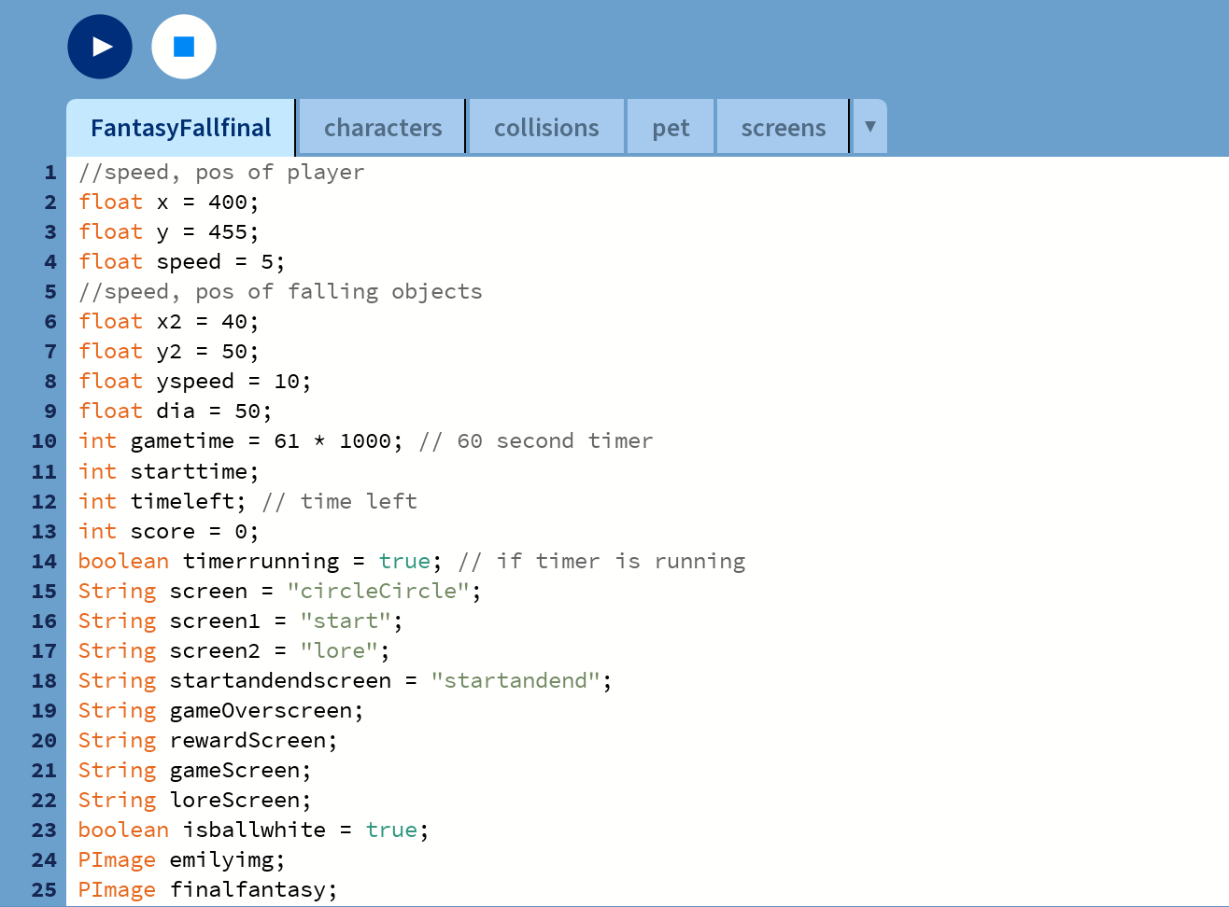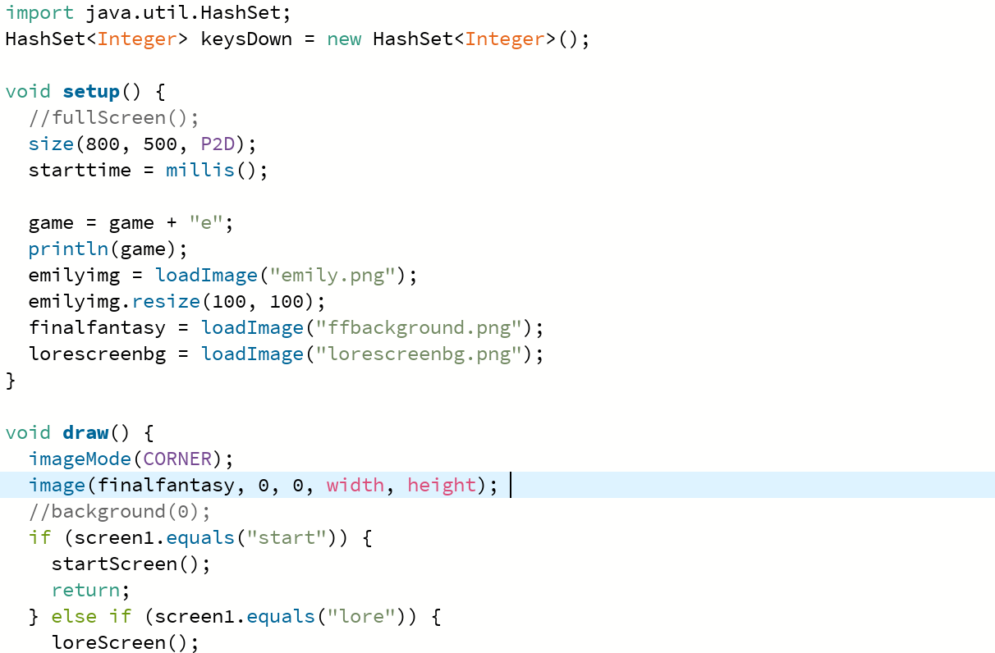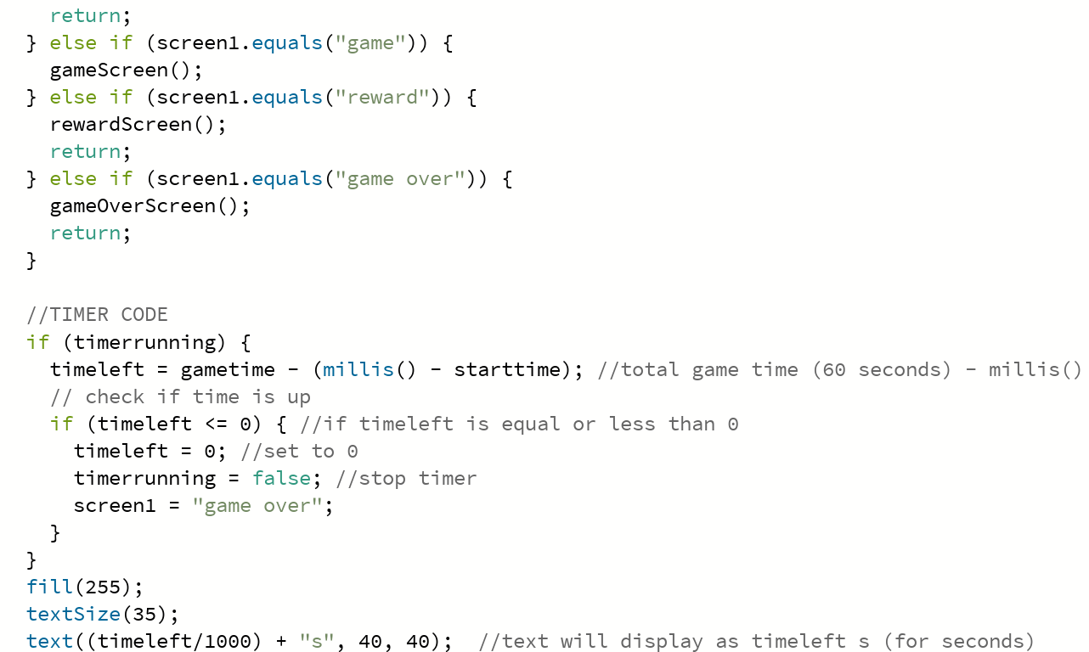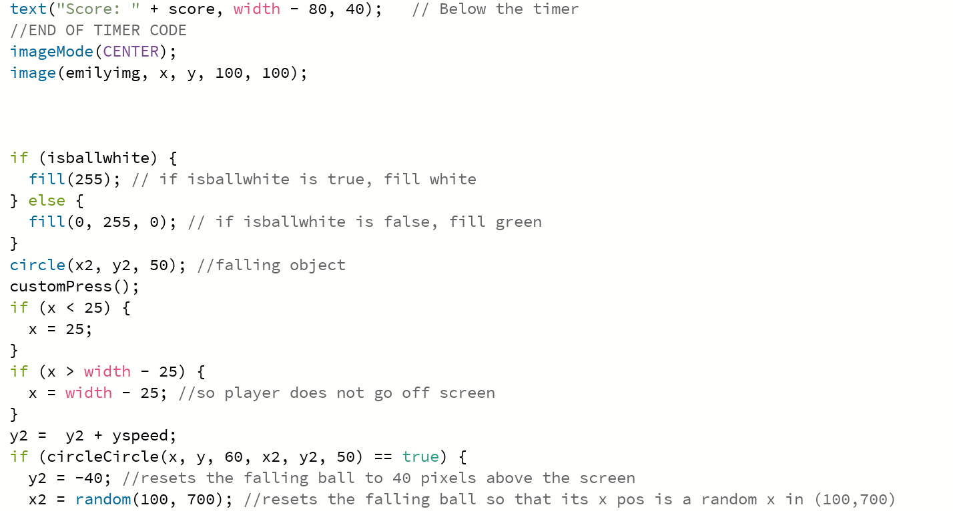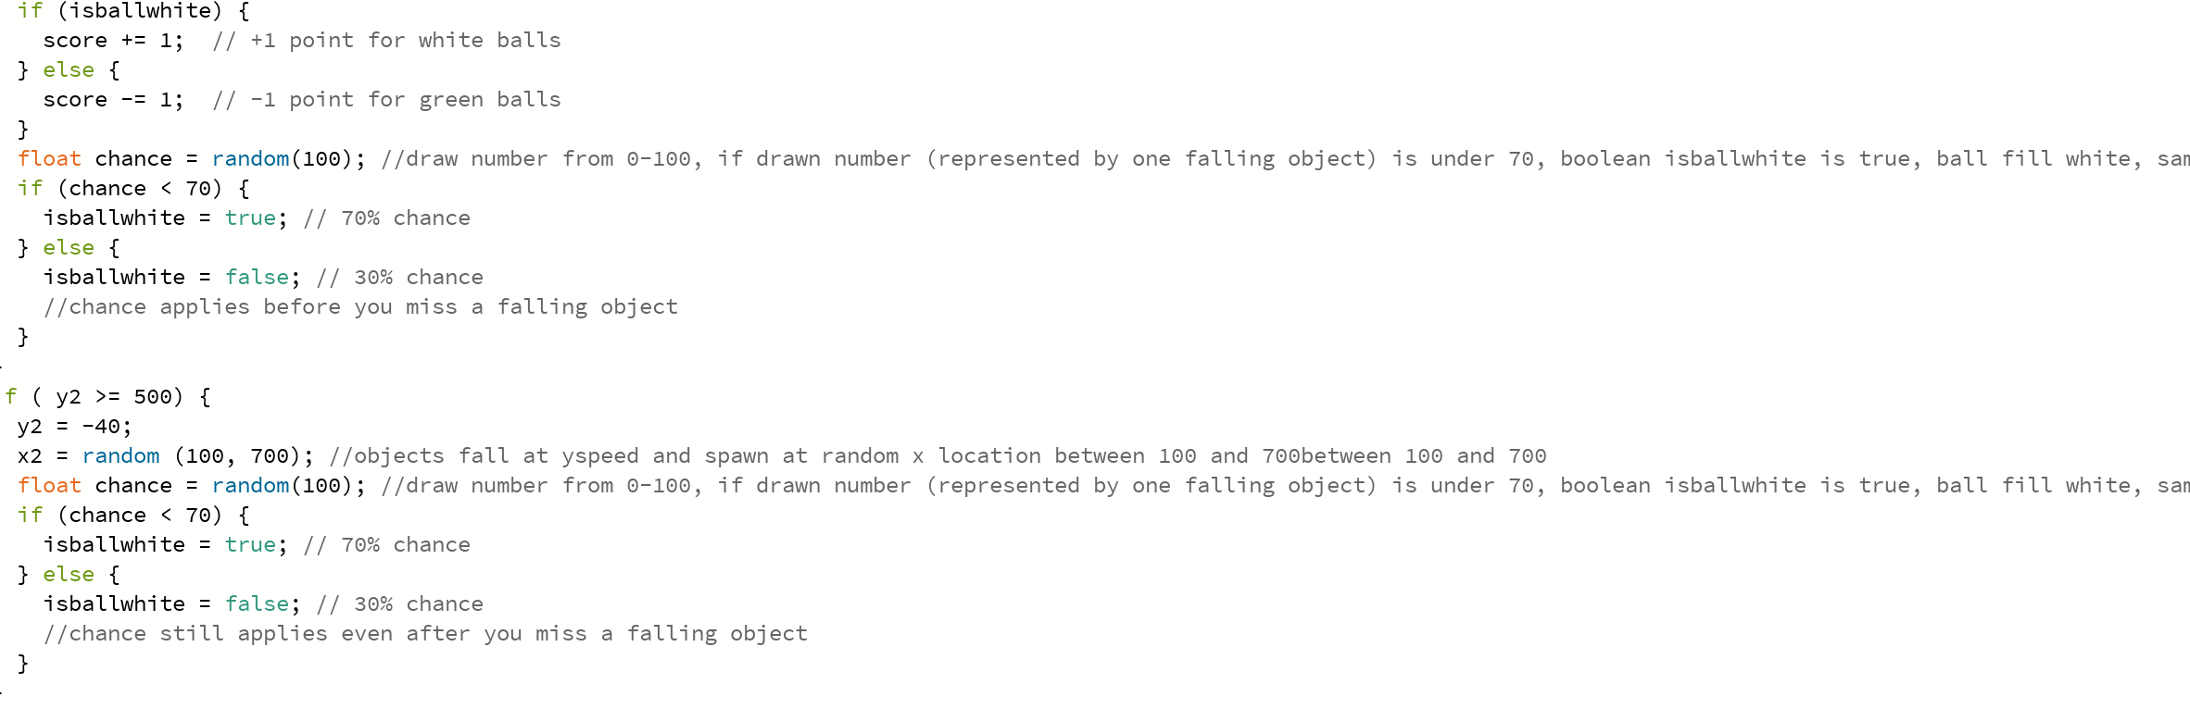
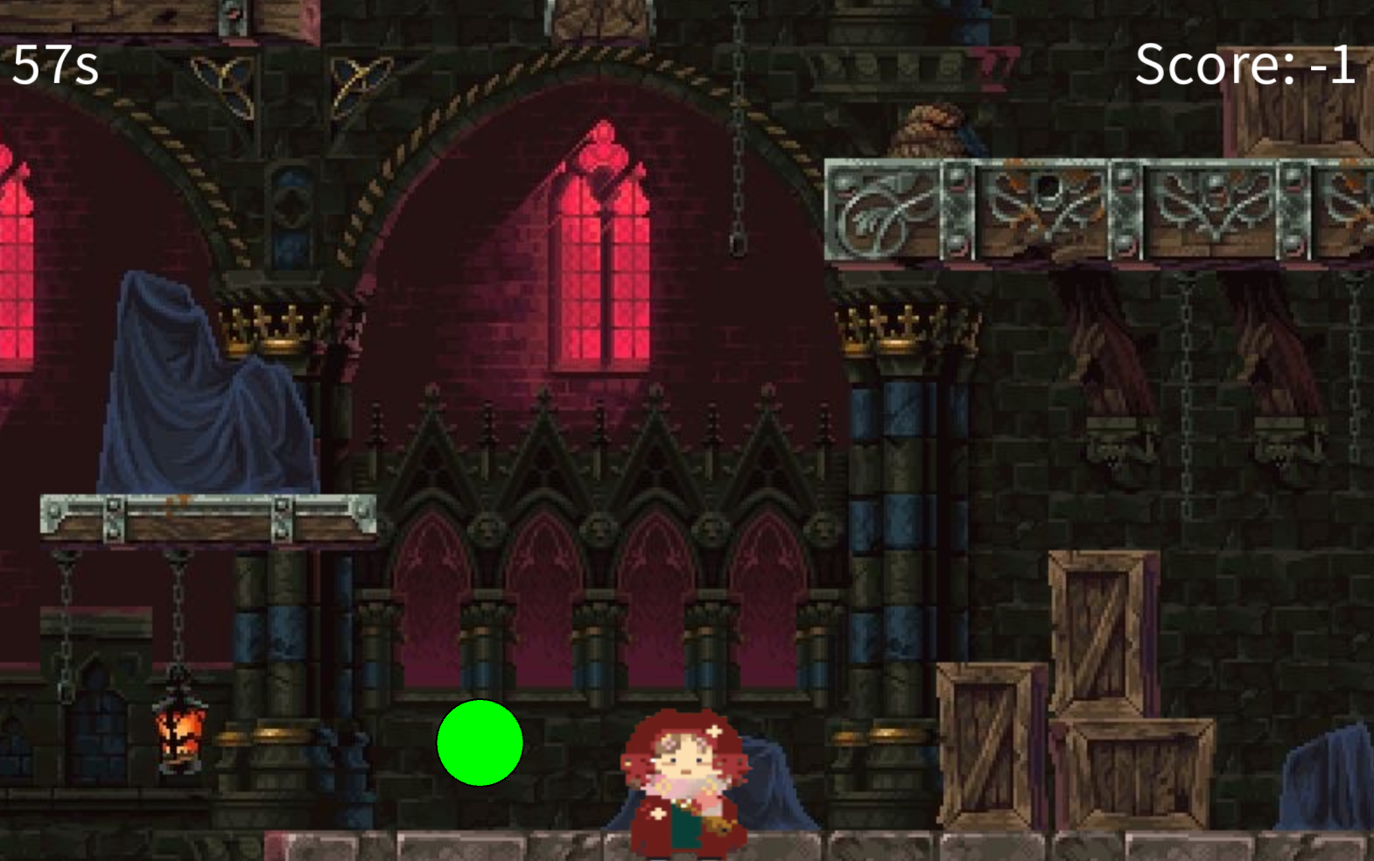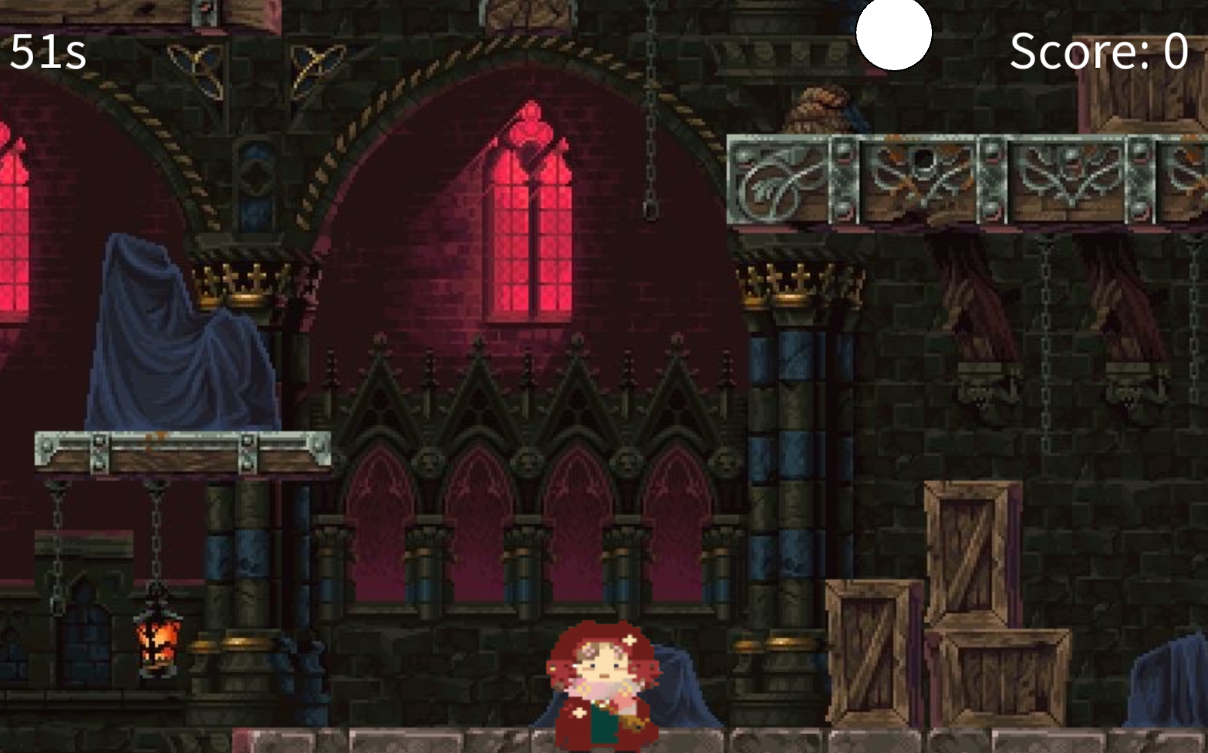
Green balls gargoyles (30% chance) and white balls armour (70% chance)
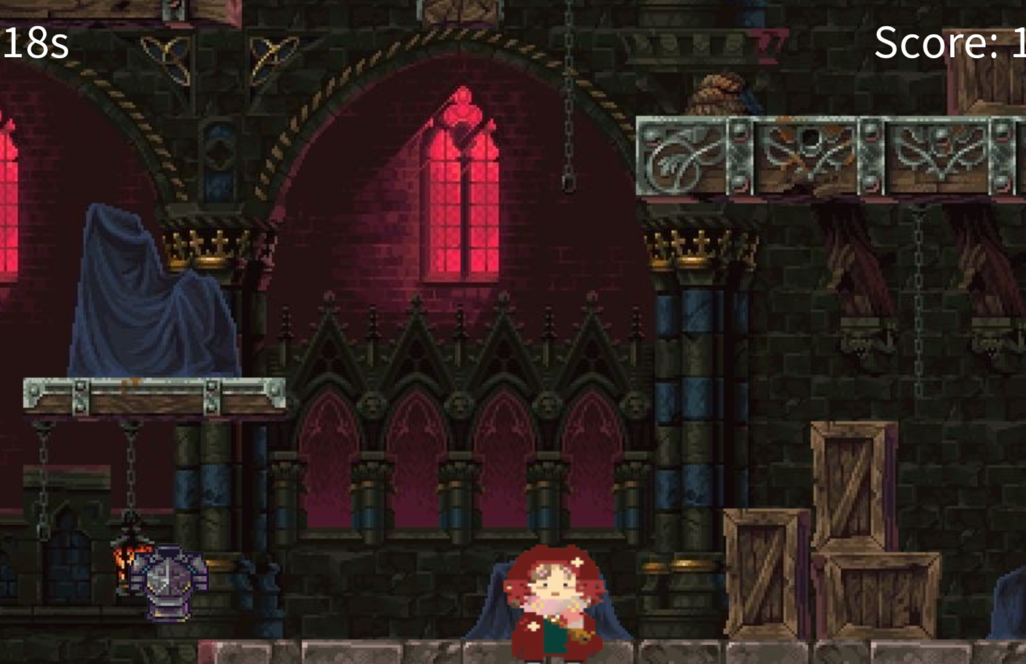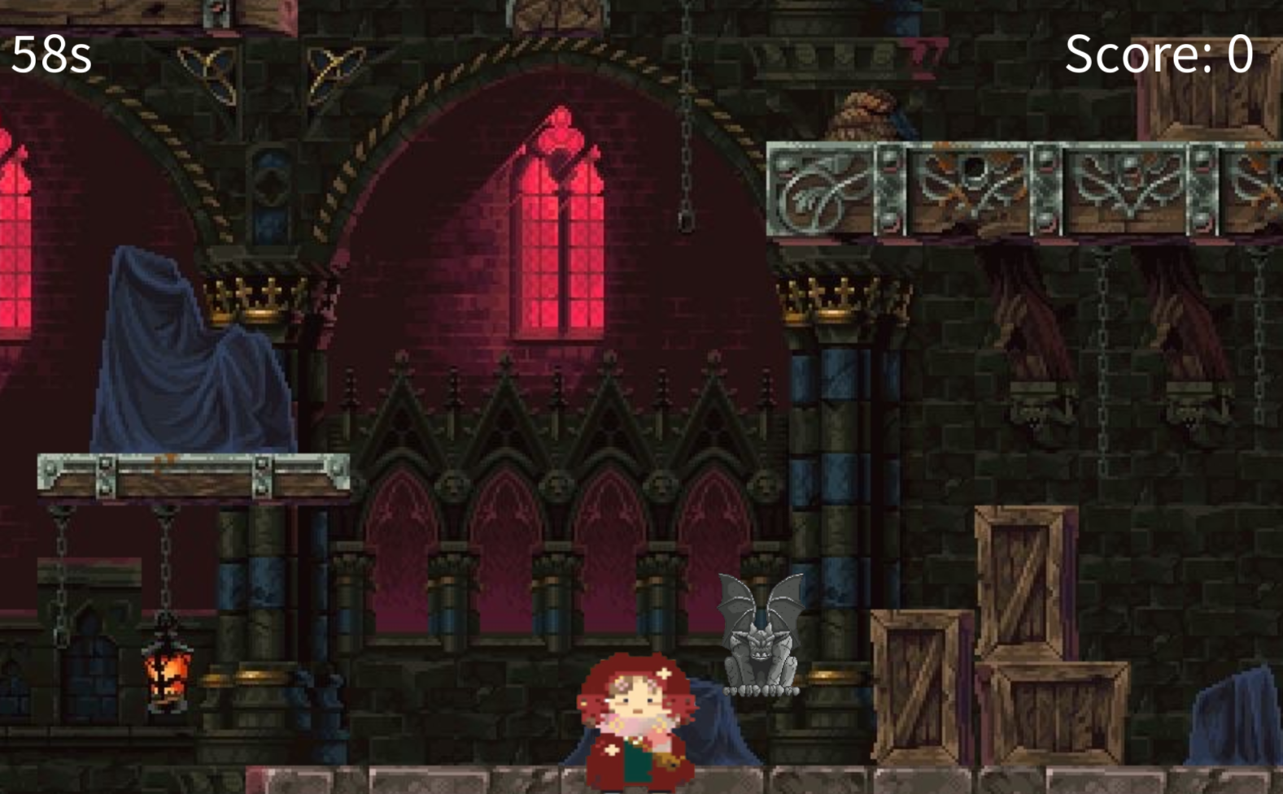
Armour and gargoyles
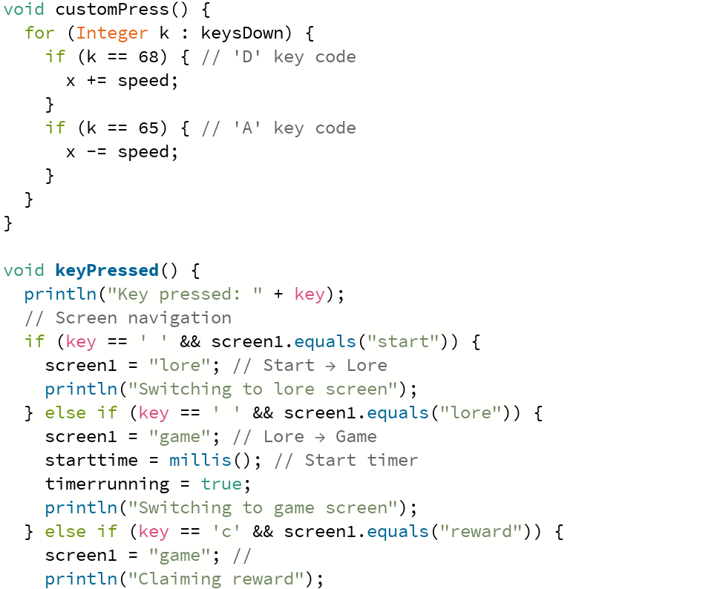
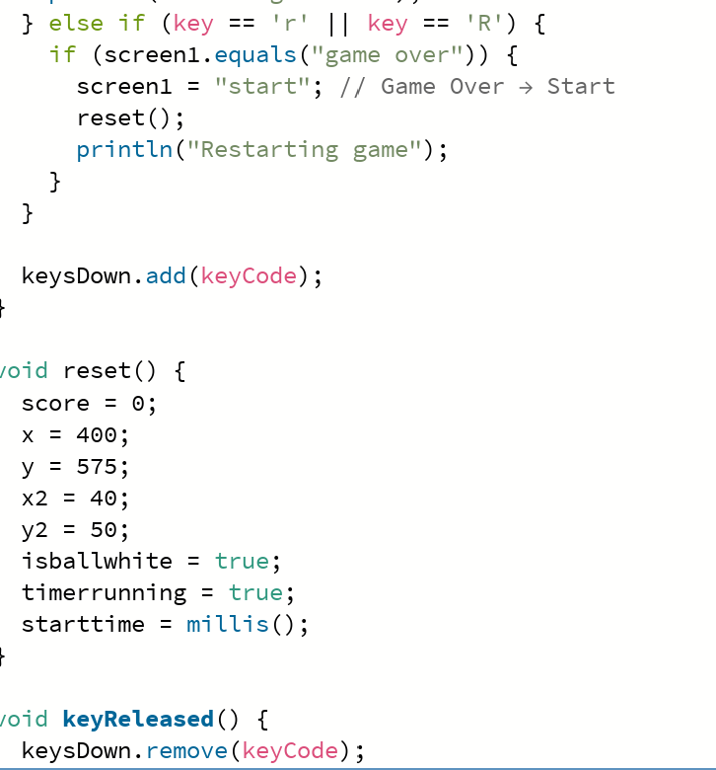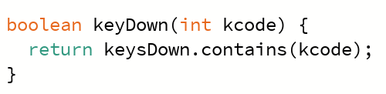

Screens page:
